**RESORT MANAGEMENT SYSTEM**

**G-92**

RITESH YAWALE

AKSHAY BHUSARI

**SYSTEM DESIGN**

Customer Activity Diagram

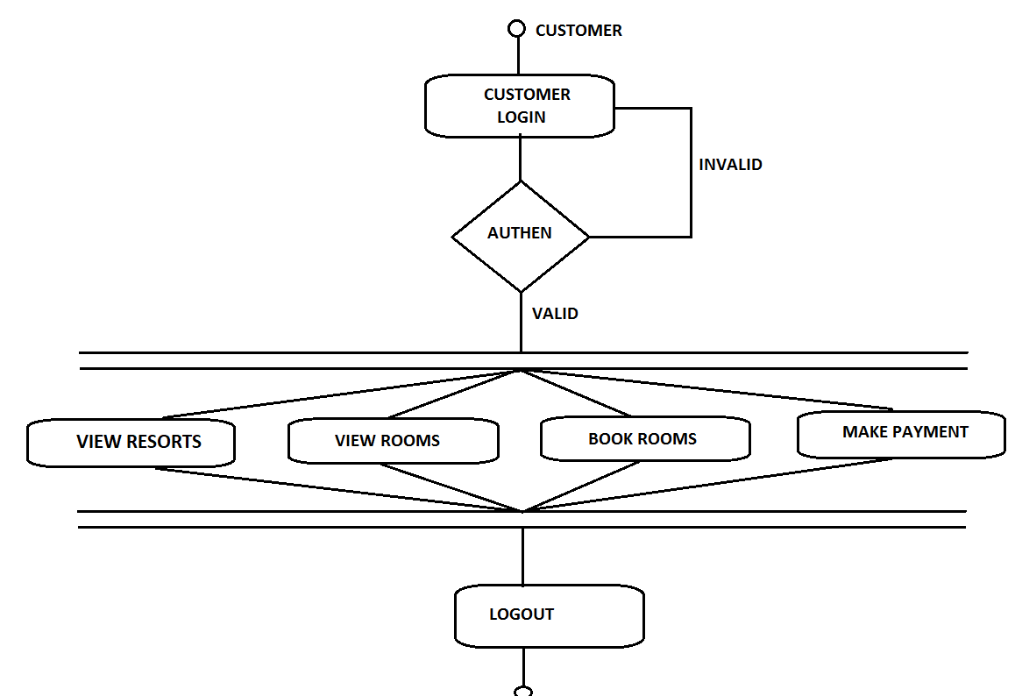

Admin Activity-Flow Diagram

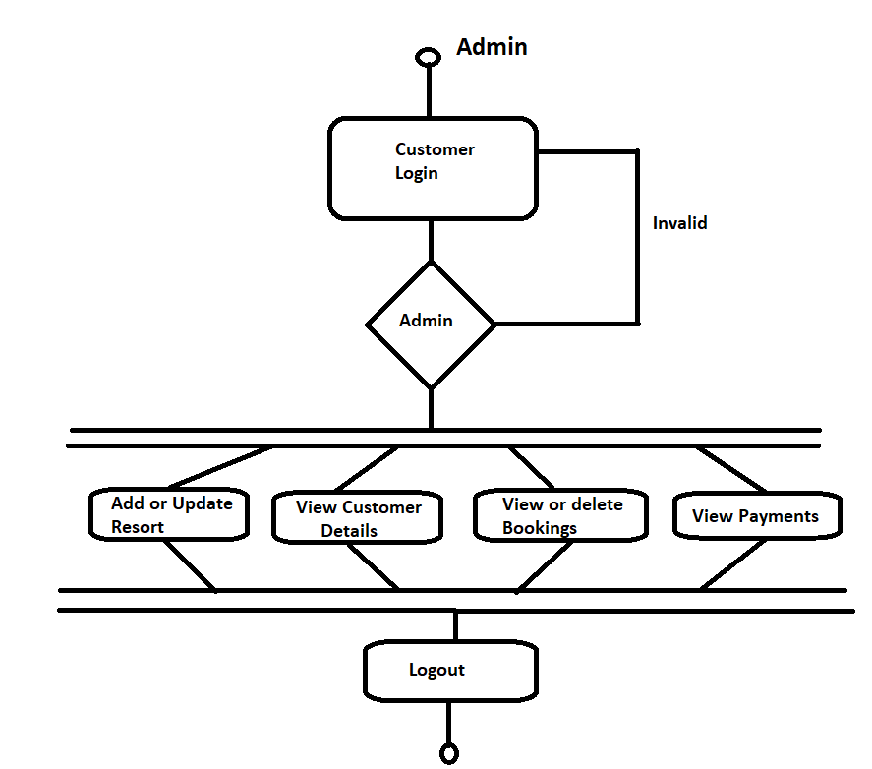

PAGE NAVIGATION AND COMPONENTS DIAGRAM

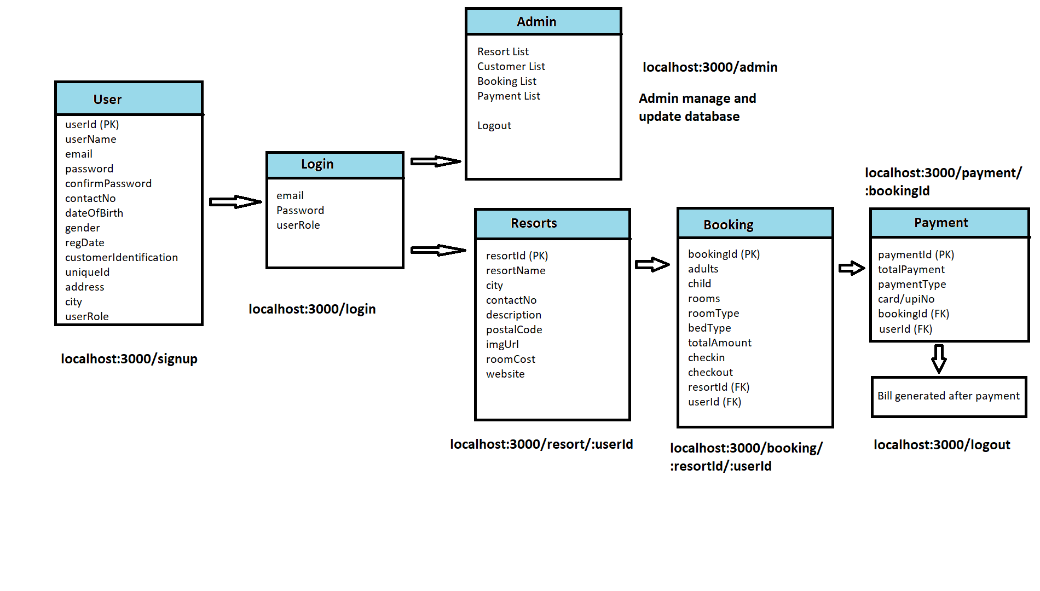

SYSTEM CLASS-DIAGRAM

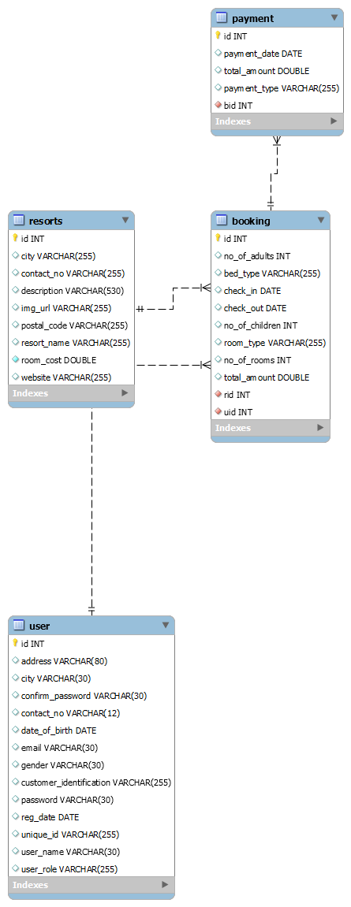

**DATA FLOW DIAGRAMS FOR DIFFERENT DEPARTMENTS**

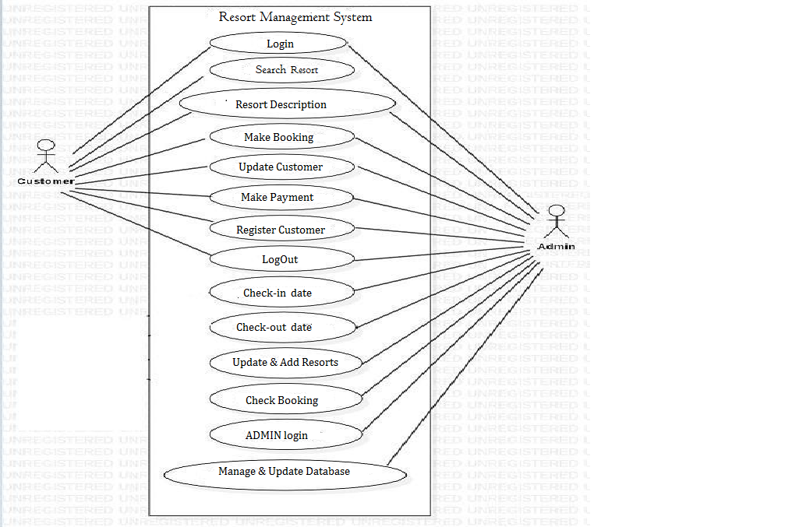

**ER DIAGRAM**

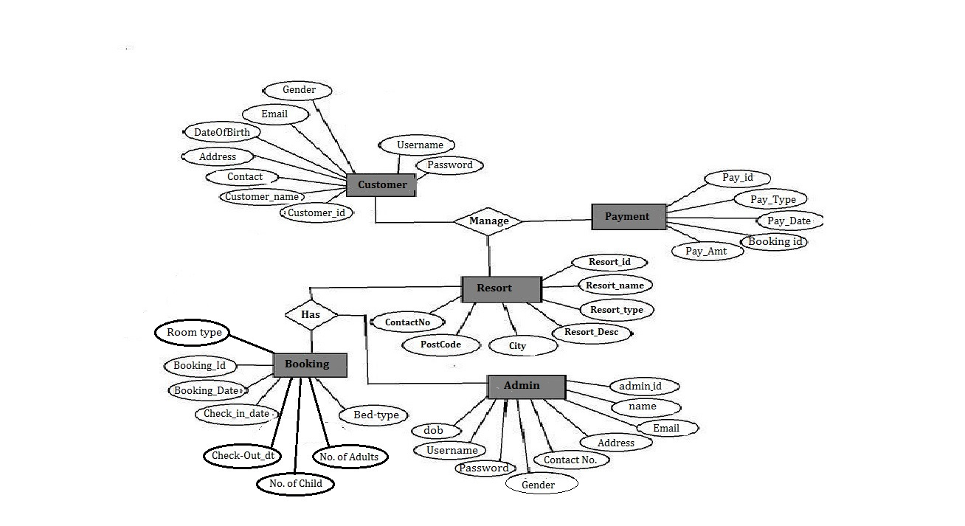

**DATABASE TABLE STRUCTURE:.**

USER TABLE

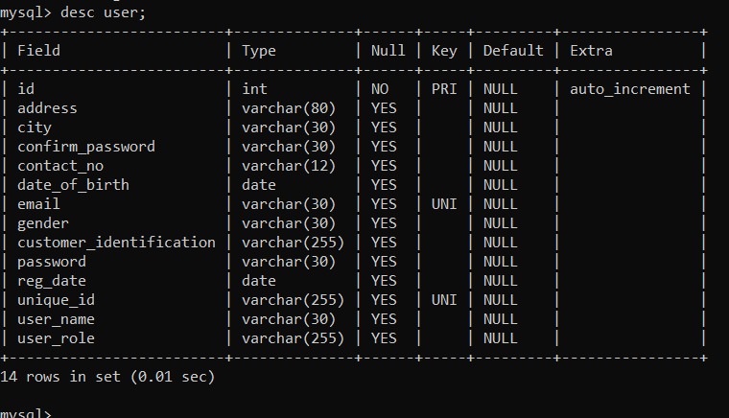

**RESORTS TABLE**

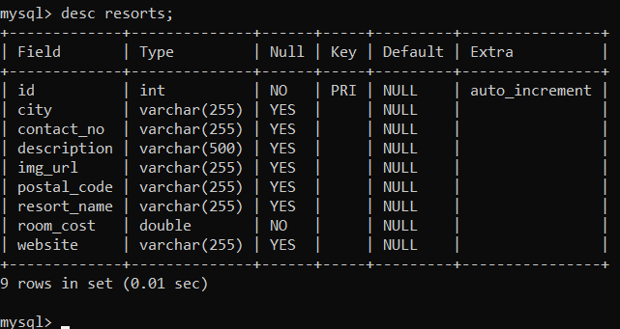

**BOOKINGS TABLE**

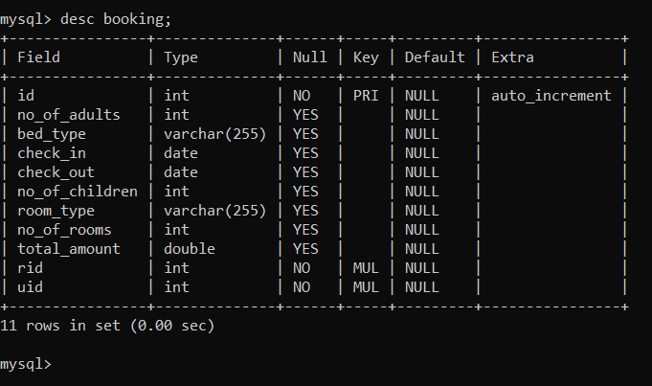

**PAYMENTS TABLE**

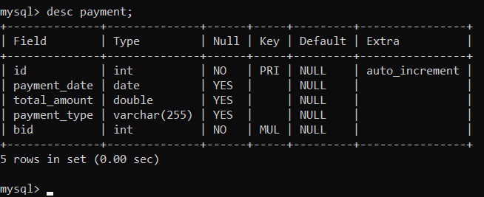

**BILLING GENERATED**

**LOGOUT**

**Customer successfully logout!!!!!!**